**Front-end Subsystem Functional Requirements, v0.2**

**Author: Josh Trimm**

**Edited by Phil Pfeiffer**

**Last Updated 12 September 2021**

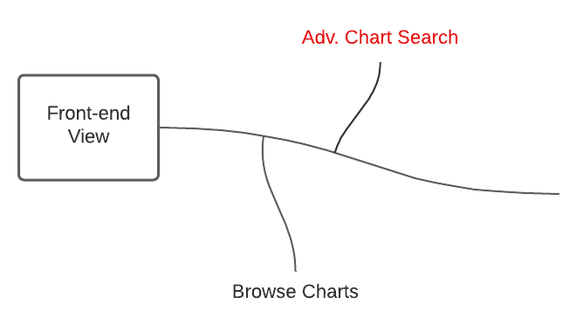

# Functional Requirements

1. The system shall allow ***Browsers*** to view all the charts***Chart Creators*** have made that are enabled.
   1. The system shall display a list of charts in block form with a description of each chart.
      1. Title, region, county, author.
2. The system shall allow ***Browsers*** to select and view specific charts.
   1. The chart view shall have the authors’ contact info, date created, region/county details, and chart title.